Install GCP-WC for Windows

1. Install Docker for Windows

Prerequisites:

* 1. One physical computer system running Windows 10 Anniversary Edition or Creators Update (Professional or Enterprise).
  2. You must install critical updates for Windows Containers to work. To check your OS version, run winver.exe. Make sure you have 14393.222 or later before continuing.

Download Docker for Windows:

1. From <https://download.docker.com/win/stable/InstallDocker.msi> download Docker for Windows.
2. Double-click InstallDocker.msi to run the installer.
3. Follow the install wizard to accept the license, authorize the installer, and proceed with the install.
4. Click Finish on the setup complete dialog to launch Docker.

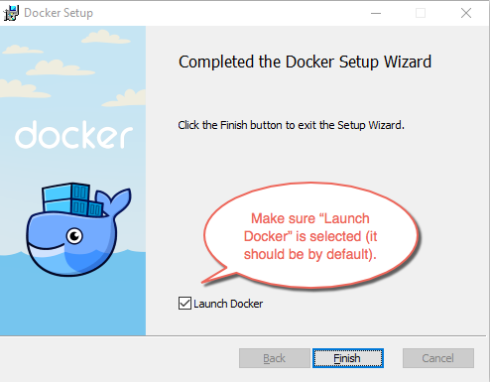

1. In order to start up Docker, Hyper-v must be enabled.
2. Open a PowerShell console as Administrator.
3. Run the following command:

**Enable-WindowsOptionalFeature -Online -FeatureName:Microsoft-Hyper-V –All**

If the command couldn't be found, make sure you're running PowerShell as Administrator.

1. When the installation has completed you need to reboot the computer.

Start Docker for Windows:

When the installation finishes, Docker starts automatically. The whale in the status bar indicates that Docker is running, and accessible from a terminal.

1. Switch to Linux Containers.

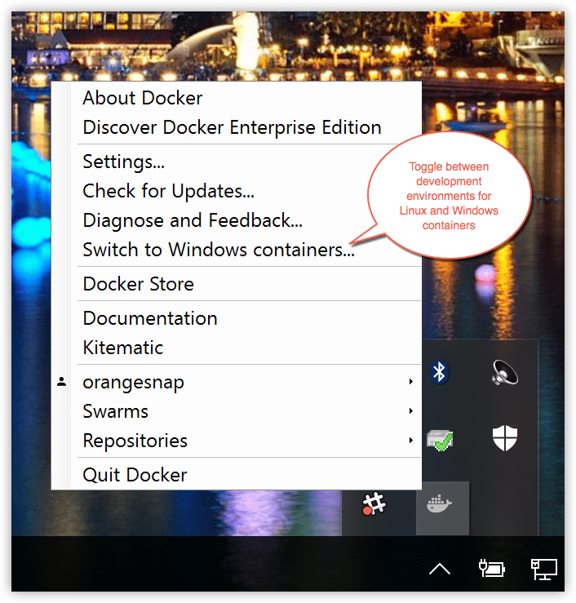

1. Pull the “python” image, which is used to the treadmill demo. Run:

**docker pull python**

1. Install Python for Windows

From <https://www.python.org/ftp/python/3.5.3/python-3.5.3-amd64.exe> download Python for Windows. (Python version does not limit, but Python3.5 is recommended.)

1. Install pywin32

From <http://sourceforge.net/projects/pywin32/files/pywin32/> download pywin32 and install.

1. Install git

From <https://git-for-windows.github.io/> download git for Windows.

1. Install GCP-WC
2. Enter a directory and clone repository:

**git clone** [**https://github.com/Xingskcs/GCP-WC.git**](https://github.com/Xingskcs/GCP-WC.git)

1. Enter gcp-wc and edit the configuration file **configure.json**

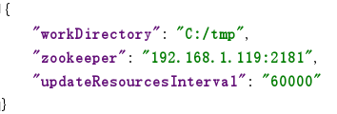

1. Run **setEnv.bat** with administrator privileges.

After running **setEnv.bat,** the configuration information is written to the system variables. Reboot the desktop for system variables to take effect.

1. package gcp-wc.

In GCP directory, run **pip install –e .**

1. Make sure **Docker for Windows** is running and run **install.bat** with administrator privileges.

After running **install.bat**, the GCP-WC is installed as Windows services. The installed services are AppCfgMgrService, AppeventService, CleanupService, EventDaemonService, ScreenMonitorService, RegisterZookeeperService, StateMonitorService, UpdateResourcesService and WatchdogService. These services can be viewed in the Task Manager.

It's possible that services are not starting because it's unable to find the executable. This is solved by adding some pywin32 related directories to system path.

**Put “{python}\Lib\site-packages\pywin32_system32” to system path.**

**Put “{python}\Lib\site-packages\win32” to system path.**

1. If you want to uninstall GCP-WC, run **uninstall.bat** with administrator privileges.

After running uninstall.bat, the services are stopped and removed.